UNIT-II

What is Relational Model?
Relational model can represented as a table with columns and rows. Each row is known as a tuple. Each table of the column has a name or attribute.
Relational Model (RM) represents the database as a collection of relations. A relation is nothing but a table of values. Every row in the table represents a collection of related data values. These rows in the table denote a real-world entity or relationship.
The table name and column names are helpful to interpret the meaning of values in each row. The data are represented as a set of relations. In the relational model, data are stored as tables. However, the physical storage of the data is independent of the way the data are logically organized.

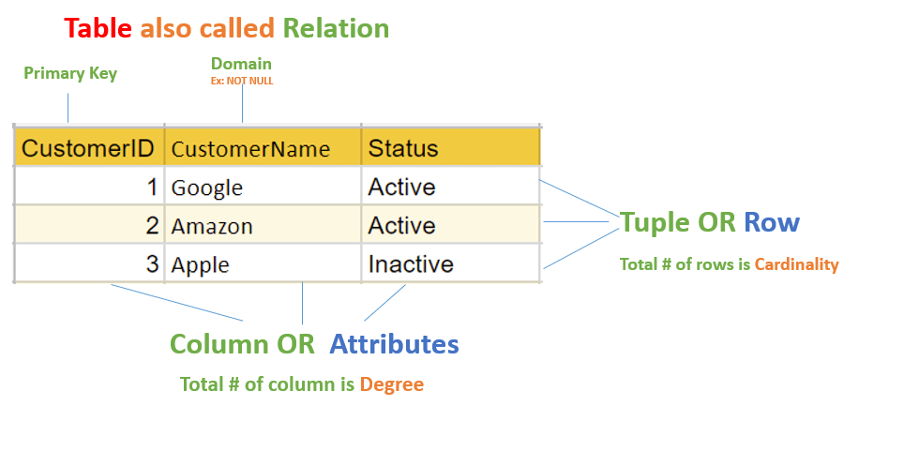

Integrity Constraints:
- Integrity constraints are a set of rules. It is used to maintain the quality of information.
- Integrity constraints ensure that the data insertion, updating, and other processes have to be performed in such a way that data integrity is not affected.
- Thus, integrity constraint is used to guard against accidental damage to the database.

Types of Integrity Constraint
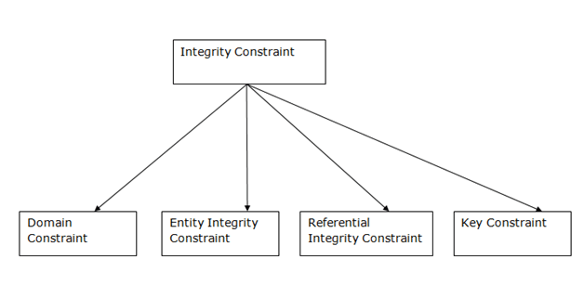

1. Domain constraints
- Domain constraints can be defined as the definition of a valid set of values for an attribute.
- The data type of domain includes string, character, integer, time, date, currency, etc. The value of the attribute must be available in the corresponding domain.

Example:
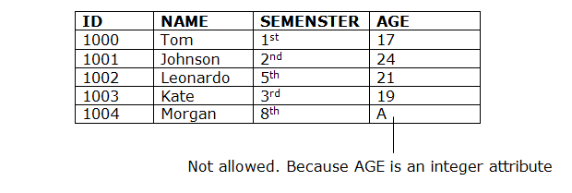

2. Entity integrity constraints
- The entity integrity constraint states that primary key value can't be null.
- This is because the primary key value is used to identify individual rows in relation and if the primary key has a null value, then we can't identify those rows.
- A table can contain a null value other than the primary key field.
Example:
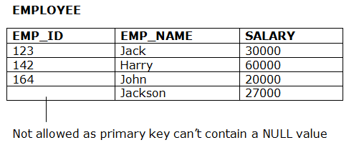
3. Referential Integrity Constraints
- A referential integrity constraint is specified between two tables.
- In the Referential integrity constraints, if a foreign key in Table 1 refers to the Primary Key of Table 2, then every value of the Foreign Key in Table 1 must be null or be available in Table 2.

Example:
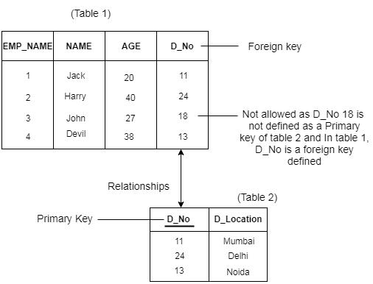

4. Key constraints
- Keys are the entity set that is used to identify an entity within its entity set uniquely.
- An entity set can have multiple keys, but out of which one key will be the primary key. A primary key can contain a unique and null value in the relational table.
Example:
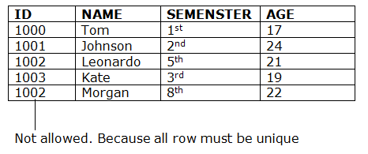
Enforcing integrity constraints:
Data integrity refers to the correctness and completeness of data within a database. To enforce data integrity, you can constrain or restrict the data values that users can insert, delete, or update in the database.
For example, the integrity of data in the pubs2 and pubs3 databases requires that a book title in the titles table must have a publisher in the publishers table. You cannot insert books that do not have a valid publisher into titles, because it violates the data integrity of pubs2 or pubs3.
Transact-SQL provides several mechanisms for integrity enforcement in a database such as rules, defaults, indexes, and triggers. These mechanisms allow you to maintain these types of data integrity:
• Requirement – requires that a table column must contain a valid value in every row; it cannot allow null values. The create table statement allows you to restrict null values for a column.
• Check or validity – limits or restricts the data values inserted into a table column. You can use triggers or rules to enforce this type of integrity.
• Uniqueness – no two table rows can have the same non-null values for one or more table columns. You can use indexes to enforce this integrity.
• Referential – data inserted into a table column must already have matching data in another table column or another column in the same table. A single table can have up to 192 references.

Types of SQL
Here are five types of widely used SQL queries.
- Data Definition Language (DDL)
- Data Manipulation Language (DML)
- Data Control Language(DCL)
- Transaction Control Language(TCL)
- Data Query Language (DQL)

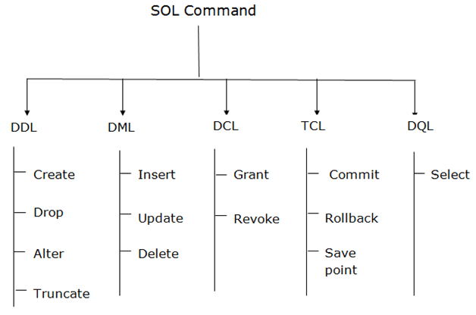
Types of SQL

What is DDL?
Data Definition Language helps you to define the database structure or schema. Let's learn about DDL commands with syntax.

CREATE
CREATE statements is used to define the database structure schema:
Syntax:
CREATE TABLE TABLE_NAME (COLUMN_NAME DATATYPES[,....]);
For example:
Create database university;
Create table students;
Create view for_students;

DROP
Drops commands remove tables and databases from RDBMS.
Syntax
DROP TABLE ;
For example:
Drop object_type object_name;
Drop database university;
Drop table student;

ALTER
Alters command allows you to alter the structure of the database.
Syntax:
To add a new column in the table
ALTER TABLE table_name ADD column_name COLUMN-definition;
To modify an existing column in the table:
ALTER TABLE MODIFY(COLUMN DEFINITION....);

TRUNCATE:
This command used to delete all the rows from the table and free the space containing the table.
Syntax:
TRUNCATE TABLE table_name;
Example:
TRUNCATE table students;

What is Data Manipulation Language?
Data Manipulation Language (DML) allows you to modify the database instance by inserting, modifying, and deleting its data. It is responsible for performing all types of data modification in a database.
There are three basic constructs which allow database program and user to enter data and information are:
Here are some important DML commands in SQL:
- INSERT
- UPDATE
- DELETE

INSERT:
This is a statement is a SQL query. This command is used to insert data into the row of a table.
Syntax:
INSERT INTO TABLE_NAME (col1, col2, col3,.... col N) VALUES (value1, value2, value3, .... valueN);
Or
INSERT INTO TABLE_NAME VALUES (value1, value2, value3, .... valueN);
For example:
INSERT INTO students (RollNo, FIrstName, LastName) VALUES ('60', 'Tom', Erichsen');

UPDATE:
This command is used to update or modify the value of a column in the table.
Syntax:
UPDATE table_name SET [column_name1= value1,...column_nameN = valueN] [WHERE CONDITION] ;
For example:
UPDATE students SET FirstName = 'Jhon', LastName= 'Wick' WHERE StudID = 3;

DELETE:
This command is used to remove one or more rows from a table.
Syntax:
DELETE FROM table_name [WHERE condition];
For example:
DELETE FROM students WHERE FirstName = 'Jhon';

What is DCL?
DCL (Data Control Language) includes commands like GRANT and REVOKE, which are useful to give "rights & permissions." Other permission controls parameters of the database system.

Examples of DCL commands:
Commands that come under DCL:
- Grant
- Revoke

Grant:
This command is use to give user access privileges to a database.
Syntax:
GRANT SELECT, UPDATE ON MY_TABLE TO SOME_USER, ANOTHER_USER;

For example:
GRANT SELECT ON Users TO 'Tom'@'localhost;

Revoke:
It is useful to back permissions from the user.
Syntax:
REVOKE privilege_name ON object_name FROM {user_name |PUBLIC |role_name}
For example:
REVOKE SELECT, UPDATE ON student FROM BCA, MCA;

What is TCL?
Transaction control language or TCL commands deal with the transaction within the database.

Commit
This command is used to save all the transactions to the database.
Syntax:
Commit;
For example:
DELETE FROM Students WHERE RollNo =25;
COMMIT;

Rollback
Rollback command allows you to undo transactions that have not already been saved to the database.
Syntax:
ROLLBACK;
Example:
DELETE FROM Students WHERE RollNo =25;

SAVEPOINT
This command helps you to sets a savepoint within a transaction.
Syntax:
SAVEPOINT SAVEPOINT_NAME;
Example:
SAVEPOINT RollNo;

What is DQL?
Data Query Language (DQL) is used to fetch the data from the database. It uses only one command:

SELECT:
This command helps you to select the attribute based on the condition described by the WHERE clause.
Syntax:
SELECT expressions FROM TABLES WHERE conditions;
For example:
SELECT FirstName FROM Student WHERE RollNo > 15;

Key Constraints
- These are called uniqueness constraints since it ensures that every tuple in the relation should be unique.
- A relation can have multiple keys or candidate keys(minimal superkey), out of which we choose one of the keys as primary key, we don’t have any restriction on choosing the primary key out of candidate keys, but it is suggested to go with the candidate key with less number of attributes.
- Null values are not allowed in primary key hence not null constraint is also a part of key constraint.

Referential Integrity Constraints
- A referential integrity constraint is specified between two tables.
- This constraint is enforced through foreign key, when an attribute in the foreign key of relation R1 have the same domain(s) as the primary key of relation R2, then the foreign key of R1 is said to reference or refer to the primary key of relation R2.
- The values of the foreign key in a tuple of relation R1 can either take the values of the primary key for some tuple in relation R2, or can take NULL values, but can’t be empty.
create table t1(id int primary key);
create table t2(id int, age int, foreign key(id) references t1(id));
Types of constraints
NOT NULL
UNIQUE
DEFAULT
CHECK
NOT NULL:
NOT NULL constraint makes sure that a column does not hold NULL value. When we don’t provide value for a particular column while inserting a record into a table, it takes NULL value by default. By specifying NULL constraint, we can be sure that a particular column(s) cannot have NULL values.
CREATE TABLE STUDENT( ROLL_NO INT NOT NULL, STU_NAME VARCHAR (35) NOT NULL, STU_AGE INT NOT NULL, STU_ADDRESS VARCHAR (235), PRIMARY KEY (ROLL_NO) );
UNIQUE:
UNIQUE Constraint enforces a column or set of columns to have unique values. If a column has a unique constraint, it means that particular column cannot have duplicate values in a table.
CREATE TABLE STUDENT
( ROLL_NO INT NOT NULL, STU_NAME VARCHAR (35) NOT NULL UNIQUE, STU_AGE INT NOT NULL, STU_ADDRESS VARCHAR (35) UNIQUE, PRIMARY KEY (ROLL_NO) );
DEFAULT:
The DEFAULT constraint provides a default value to a column when there is no value provided while inserting a record into a table.
CREATE TABLE STUDENT( ROLL_NO INT NOT NULL, STU_NAME VARCHAR (35) NOT NULL, STU_AGE INT NOT NULL, EXAM_FEE INT DEFAULT 10000);

CHECK:
This constraint is used for specifying range of values for a particular column of a table. When this constraint is being set on a column, it ensures that the specified column must have the value falling in the specified range.
CREATE TABLE STUDENT( ROLL_NO INT NOT NULL CHECK(ROLL_NO >1000) , STU_NAME VARCHAR (35) NOT NULL);
Types of Keys
- Keys play an important role in the relational database.
- It is used to uniquely identify any record or row of data from the table. It is also used to establish and identify relationships between tables.
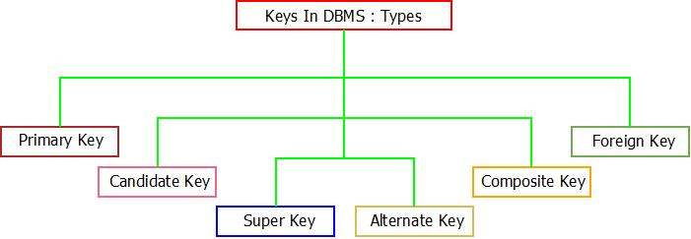

PRIMARY KEY
Is a column or group of columns in a table that uniquely identify every row in that table. The Primary Key can't be a duplicate meaning the same value can't appear more than once in the table. A table cannot have more than one primary key.
Rules for defining Primary key:
Two rows can't have the same primary key value
The primary key field cannot be null.
The value in a primary key column can never be modified or updated if any foreign key refers to that primary key.
CREATE TABLE Persons (
ID int NOT NULL,
LastName varchar(255) NOT NULL,
FirstName varchar(255),
Age int,
PRIMARY KEY (ID)
);
Foreign Keys
- Foreign keys are the columns of a table that points to the primary key of another table. They act as a cross-reference between tables.
- It may be worth noting that unlike, Primary Key of any given relation, Foreign Key can be NULL as well as may contain duplicate tuples i.e. it need not follow uniqueness constraint.
CREATE TABLE Orders (
OrderID int NOT NULL,
OrderNumber int NOT NULL,
PersonID int,
PRIMARY KEY (OrderID),
FOREIGN KEY (PersonID) REFERENCES Persons(ID)
);
CANDIDATE KEY
- Candidate keys are defined as the minimal set of fields which can uniquely identify each record in a table. It is an attribute or a set of attributes that can act as a Primary Key for a table
- to uniquely identify each record in that table. There can be more than one candidate key.
- The value of Candidate Key is unique and non-null for every tuple.
- The candidate key can be simple (having only one attribute) or composite as well.
Alternate Key:
- It is a column or group of columns in a table that uniquely identify every row in that table. A table can have multiple choices for a primary key but only one can be set as the primary key. All the keys which are not primary key are called an Alternate Key.
Composite key
- A key that has more than one attributes is known as composite key. It is also known as compound key.
- Lets consider a table Sales. This table has four columns (attributes) – cust_Id, order_Id, product_code & product_count.
cust_Id order_Id product_code product_count
-------- -------- ------------ -------------
C01 O001 P007 23
C02 O123 P007 19
C02 O123 P230 82
C01 O001 P890 42
- it is safe to assume that the key should be having more than one attributes:
Key in above table: {cust_id, product_code}
Super Key
- A super key is a set of one or more attributes (columns), which can uniquely identify a row in a table. Often we get confused between super key and candidate key
- Candidate keys are selected from the set of super keys, the only thing we take care while selecting candidate key is: It should not have any redundant attribute. That’s the reason they are also termed as minimal super key..
Logical database design
Logical database design is the process of transforming (or mapping) a conceptual schema of the application domain into a schema for the data model underlying a particular DBMS, such as the relational or object-oriented data model.
- Entity in ER Model is changed into tables, or we can say for every Entity in ER model, a table is created in Relational Model.
- And the attributes of the Entity gets converted to columns of the table.
- And the primary key specified for the entity in the ER model, will become the primary key for the table in relational model.
- ER diagram is converted into the tables in relational model.
- This is because the relational model can be easily implemented by MYSQL Oracle etc.

Entity
- Consider we have entity STUDENT in ER diagram with attributes Roll Number, Student Name and Class.
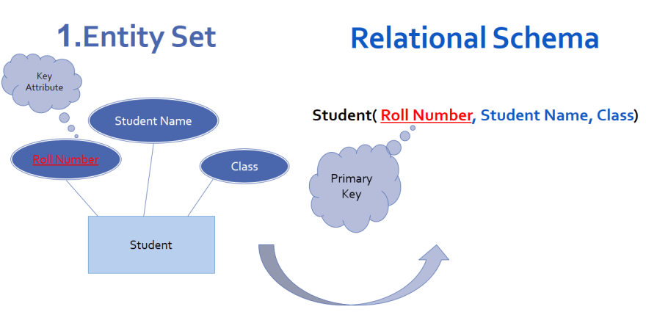

- Entity set with multi valued attribute:
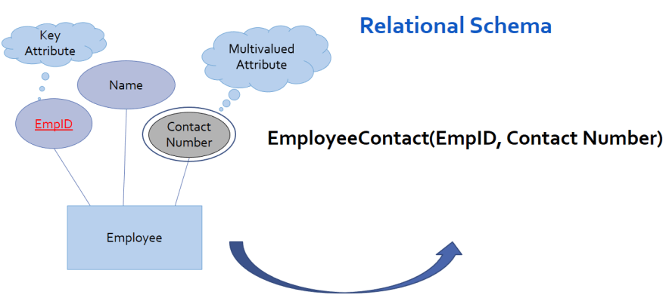
Consider we have entity set Employee with attributes Employee ID, Name and Contact number.
Hence to convert entity with multivalued attribute into relational schema
separate relation is created for multivalued attribute
Entity set with Composite attribute:
- Consider entity set student with attributes Roll Number, Student Name and Class. here student name is composite attribute as it has further divided into First name, last name.
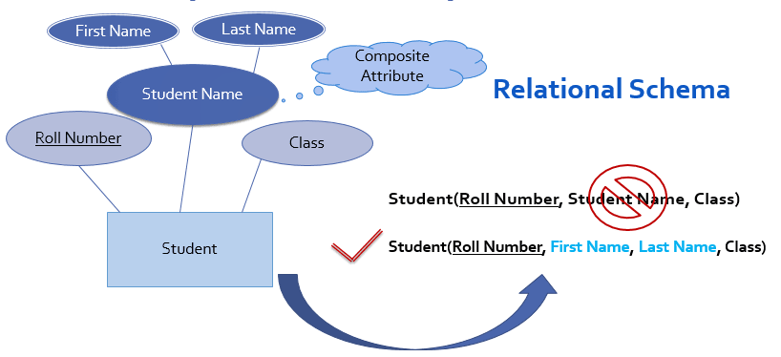

1:M (one to many) Relationship:
- Consider 1:M relationship set enrolled exist between entity sets student and course as follow,
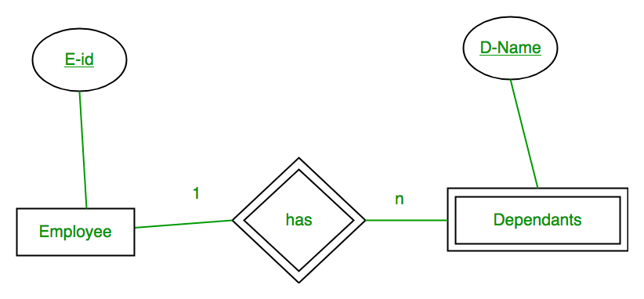
First Convert each entity and relationship to tables. Employee table corresponds to Employee Entity with key as E-Id. Similarly Dependents table corresponds to Dependent Entity with key as D-Name and E-Id. represents the relationship between Employee and Dependents (Which employee has which dependents). So it will take attribute E-Id from Employee and D-Name from Dependents.

Database design steps
Requirement Analasys
Conceptual DB design
Logical DB Design
Security Design
Physical DB Design
Schema Refinement

Views in SQL
- Views in SQL are considered as a virtual table. A view also contains rows and columns.
- To create the view, we can select the fields from one or more tables present in the database.
- A view can either have specific rows based on certain condition or all the rows of a table.

Sample table:
Student_Detail
STU_ID | NAME | ADDRESS
1 | Stephan | Delhi
2 | Kathrin | Noida
3 | David | Ghaziabad
4 | Alina | Gurugram
Student_Marks
STU_ID | NAME | MARKS | AGE
1 | Stephan | 97 | 19
2 | Kathrin | 86 | 21
3 | David | 74 | 18
4 | Alina | 90 | 20
5 | John | 96 | 18

1. Creating view
A view can be created using the CREATE VIEW statement. We can create a view from a single table or multiple tables.
Syntax:
CREATE VIEW view_name AS SELECT column1, column2..... FROM table_name WHERE condition;

2. Creating View from a single table
In this example, we create a View named DetailsView from the table Student_Detail.
Query:
CREATE VIEW DetailsView AS SELECT NAME, ADDRESS FROM Student_Details WHERE
STU_ID < 4;
Just like table query, we can query the view to view the data.
SELECT * FROM DetailsView;
Output:
NAME | ADDRESS
Stephan | Delhi
Kathrin | Noida
David | Ghaziabad

3. Creating View from multiple tables
View from multiple tables can be created by simply include multiple tables in the SELECT statement.
In the given example, a view is created named MarksView from two tables Student_Detail and Student_Marks.
Query:
CREATE VIEW MarksView AS SELECT Student_Detail.NAME, Student_Detail.ADDRESS,
Student_Marks.MARKS FROM Student_Detail, Student_Mark
WHERE Student_Detail.NAME = Student_Marks.NAME;
To display data of View MarksView:
SELECT * FROM MarksView;
NAME | ADDRESS | MARKS
Stephan | Delhi | 97
Kathrin | Noida | 86
David | Ghaziabad | 74
Alina | Gurugram | 90

4. Deleting View
A view can be deleted using the Drop View statement.
Syntax
DROP VIEW view_name;
Example:
If we want to delete the View MarksView, we can do this as:
DROP VIEW MarksView;

Executed Queries on Views:
mysql> create table student_detail(std_id int,name varchar(20),address varchar(20));
Query OK, 0 rows affected (0.33 sec)

mysql> insert into student_detail(std_id,name,address) values (1,'stephan','delhi'),(2,'kathrin','noida'),(3,'david','ghaziabad'),(4,'alina','gurugram');
Query OK, 4 rows affected (0.11 sec)
Records: 4 Duplicates: 0 Warnings: 0

mysql> create table student_marks(std_id int,name varchar(20),marks int,age int);
Query OK, 0 rows affected (0.11 sec)
mysql> insert into student_marks(std_id,name,marks,age) values (1,'stephan',97,19),(2,'kathrin',86,21),(3,'david',74,18),(4,'alina',90,19),(5,’john’,96,18);
Query OK, 5 rows affected (0.02 sec)
Records: 5 Duplicates: 0 Warnings: 0

mysql> create view detailsview as select name,address from student_detail where std_id<4;
Query OK, 0 rows affected (0.17 sec)

mysql> select * from detailsview;
+---------+-----------+
| name | address |
+---------+-----------+
| stephan | delhi |
| kathrin | noida |
| david | ghaziabad |
+---------+-----------+
3 rows in set (0.08 sec)
mysql> create view marksview as select student_detail.name, student_detail.address, student_marks.marks from student_detail, student_marks where student_detail.name=student_marks.name;
Query OK, 0 rows affected (0.09 sec)

mysql> select * from marksview;
+---------+-----------+-------+
| name | address | marks |
+---------+-----------+-------+
| stephan | delhi | 97 |
| kathrin | noida | 86 |
| david | ghaziabad | 74 |
| alina | gurugram | 90 |
+---------+-----------+-------+
4 rows in set (0.00 sec)

mysql> drop view marksview;
Query OK, 0 rows affected (0.00 sec)
mysql> create view marksview1 as select student_detail.name, student_marks.marks,student_marks.age from student_detail, student_marks where student_detail.std_id=student_marks.std_id;
Query OK, 0 rows affected (0.20 sec)

mysql> select * from marksview1;
+------+-------+------+
| name | marks | age |
+------+-------+------+
| xyz | 98 | 18 |
| pqr | 95 | 19 |
| abc | 68 | 17 |
| uvw | 78 | 18 |
+------+-------+------+
4 rows in set (0.09 sec)

Update SQL View:
The SQL view created can also be modified. We can do the following operations with the SQL VIEW.
But, all views are not updatable. A SQL view can be updated if the following conditions are satisfied.
- The view is defined based on only one table.
- The view should not have any field which is made of an aggregate function.
- The view must not have GROUP BY, HAVING or DISTINCT clause in its definition.
- The view should not be created using any nested query.
- The selected output fields of the view must not use constants, string or value expressions.
- If you want to update a view based on another view then that view should be updatable.

Updating a SQL View
We can use the CREATE OR REPLACE VIEW statement to modify the SQL view.
Syntax
CREATE OR REPLACE VIEW view_name AS SELECT column1,coulmn2,..FROM table_name
WHERE condition;

Example: If we want to update the view marksview1 and remove the attribute "Age" from in the view then the query would be:
Query
mysql> create or replace view marksview1 as select student_detail.name, student_marks.marks from student_detail, student_marks where student_detail.std_id=student_marks.std_id;
Query OK, 0 rows affected (0.03 sec)
The above CREATE OR REPLACE VIEW statement would create a virtual table based on the result of the SELECT statement. Now, you can query the SQL VIEW as follows to see the output:

Output
mysql> select * from marksview1;
+---------+-------+
| name | marks |
+---------+-------+
| stephan | 97 |
| kathrin | 86 |
| david | 74 |
| alina | 90 |
+---------+-------+
4 rows in set (0.03 sec)

